**Worksheet-3.3**

**Student Name:- Pushpraj Roy UID:- 20BCS9866**

**Branch:- BE- CSE Section/Group:- WM_617 “A”**

**Subjetct Code:- 20CSP-321 Semester:- 5th**

**Subject Name:- PBLJ Lab**

1. **Aim/ Overview of the practical:-**

Write a JSP application to demonstrate the expression tag by using mathematical operation.

1. **S/W Requirements:-**

* Eclipse
* VS Code

1. **Algorithm/ PsuedoCode:**

* Create a index.jsp file in a webapp directory.
* Create a package named as fun and create a java file named as

functions.java .

* Functions.java file contains the logic for Performing the Operation

such as addition, Division and Subtraction.

* At Last start the server and display the output on the web browser.
* EXIT

1. **Code :-**

**Index.jsp**

<%@ page language="java" contentType="text/html; charset=ISO-8859-1"

pageEncoding="ISO-8859-1"%>

<!DOCTYPE html>

<html>

<head>

<meta charset="ISO-8859-1">

<title>Calculator</title>

<style>

body{

background: black;

color: white;

}

h1{

text-align: center;

}

.Paramter{

border: 2px solid white;background: blue;

padding: 5px;

max-width: 500px;

margin: auto;

font-size: 19px;

}

button{

position: relative;

left: 170px;

margin: 10px; width: 60px;height:30px;

cursor:pointer;border-radius:5px;

}

button:hover{

background: orange;

}

</style>

</head>

<body>

<br/>

<div class="Paramter">

<form name="funcitons" action="<%=request.getContextPath()%>/functions"

method="post" >

<h1>Mathematical Operation</h1>

<input type="radio" id="add" name="fun" value="+"> Addition <br/>

<input type="radio" id="mul" name="fun" value="*"> Multiplication

<br/>

<input type="radio" id="sub" name="fun" value="-"> Subtraction

<br/><br/>

Enter the First Value: <input type="number" name="fst"><br/><br/>

Enter the Second Value: <input type="number" name="snd"><br/>

<button type="submit">Submit</button>

DEPARTMENT OF

COMPUTER SCIENCE & ENGINEERING

<button value="Reset">Reset</button>

</form>

<h1>Ans = <%=request.getAttribute("ans") %></h1>

</div>

</body>

</html>

**Functions.java**

package fun;

import java.io.IOException;

import javax.servlet.ServletException;

import javax.servlet.annotation.WebServlet;

import javax.servlet.http.HttpServlet;

import javax.servlet.http.HttpServletRequest;

import javax.servlet.http.HttpServletResponse;

/**

* Servlet implementation class functions

*/

@WebServlet(name="functions",urlPatterns={"/functions"})

public class functions extends HttpServlet {

protected void doPost(HttpServletRequest request, HttpServletResponse

response) throws ServletException, IOException {

String a=request.getParameter("fst");

String b=request.getParameter("snd");

String fun=request.getParameter("fun");

try {

System.out.println(a+fun+b);

DEPARTMENT OF

COMPUTER SCIENCE & ENGINEERING

int i1=Integer.parseInt(a);

int i2=Integer.parseInt(b);

int ans=0;

if(fun.equals("+")) {

ans=i1+i2;

}else if(fun.equals("-")) {

ans=i1-i2;

}else if(fun.equals("*")) {

ans=i1*i2;

}

// System.out.println(ans);

request.setAttribute("ans", ans);

request.getRequestDispatcher("index.jsp").forward(request,response);

}catch(Exception e) {

System.out.println(e);

}

}

}

1. **Result/Output/Writing Summary:-**

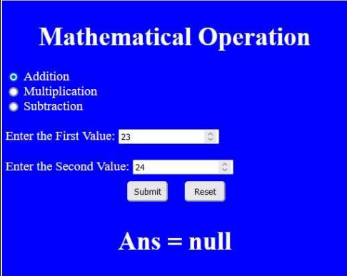

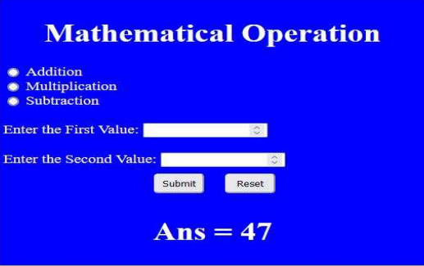

1. **Learning outcomes (What I have learnt):**

* Learn About the servlet
* Learn about jsp and dynamic web project
* Learn about the tomcat server and its integrations with the java.

**Evaluation Grid (To be created as per the SOP and Assessment guidelines by the faculty):**

|  |  |  |  |
| --- | --- | --- | --- |
| Sr. No. | Parameters | Marks Obtained | Maximum Marks |
| 1. |  |  |  |
| 2. |  |  |  |
| 3. |  |  |  |